**Online Food Store Using Angula**

0:03

hello guys in this tutorial we want to

0:06

create our angular app first of all open

0:09

up the vs code then go to the terminal

0:12

menu and click on new terminal as you

0:15

can see the default profile of vs codes

0:18

terminal is set on cmd we want to set

0:22

the default profile to git bash because

0:25

our commands will be similar to macos

0:28

and linux based operating systems click

0:30

on this arrow icon and click on select

0:33

default profile and select git bash

0:36

click on plus icon as you can see our

0:39

profile is set to bash kill the previous

0:42

terminal that was set on cmd now we want

0:45

to create the project's folder go to the

0:47

desktop directory

0:49

create footmine folder

0:52

then go inside it

0:56

now we want to install angular cli as a

0:59

global package on our system so write

1:03

npm

1:04

install

1:06

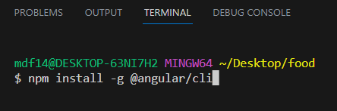

g that means global package

1:09

angular for slash cli and press enter

1:14

now we want to verify that ngcli is

1:18

installed on our computer successfully

1:21

we need to write ng dash dash version

1:24

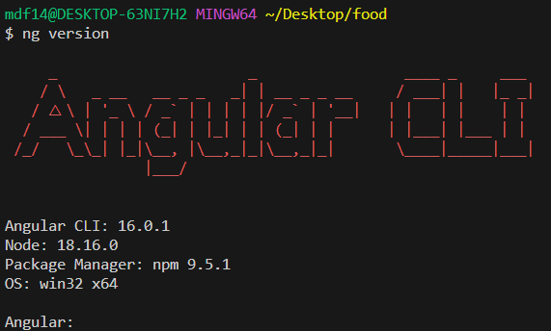

by seeing this red angular cli on our

1:27

terminal we can make sure that it is

1:30

installed successfully now open up the

1:33

project folder inside the vs code by

1:36

writing code dots

1:39

you will see a new instance of vs code

1:42

on your screen ignore or close the

1:45

previous instance and start working with

1:48

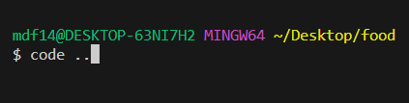

the new instance once again go to the

1:50

terminal menu and click on new terminal

1:54

and create your angular app with the

1:56

name of frontend inside the footmine

1:59

folder by writing ng new

2:02

frontend but there is an argument for

2:05

skipping all the tests we don't want to

2:08

use any test inside this project so it's

2:11

better to use these arguments by writing

2:14

skip dash tests then press enter we want

2:19

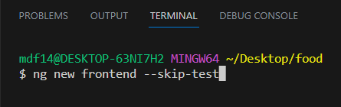

to have angular routing so we press y to

2:23

say yes

2:24

then press enter to use css as default

2:28

style sheet for our project

2:32

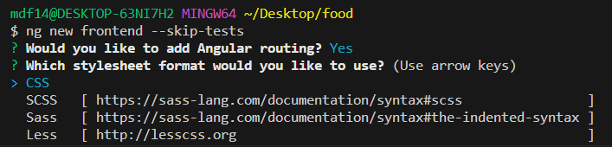

go to the front-end folder by writing cd

2:35

front end

2:36

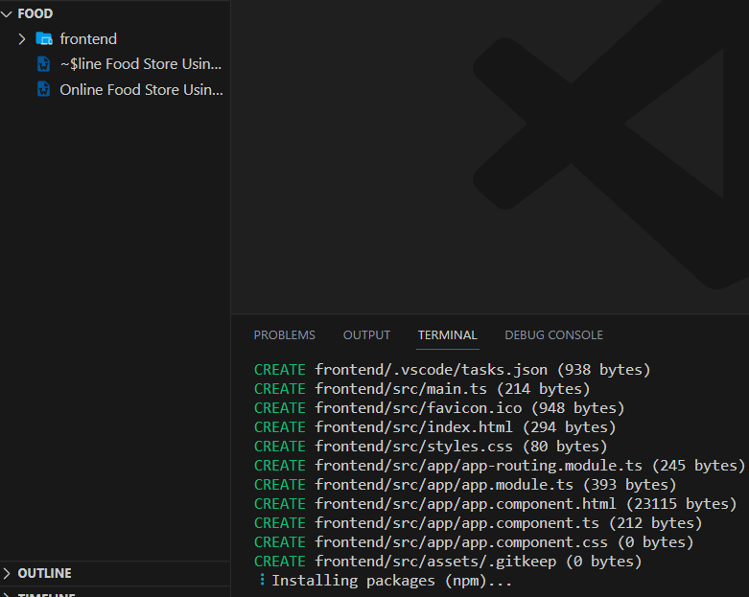

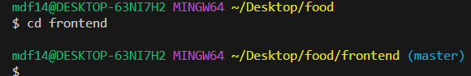

now for serving our angular application

2:39

inside the browser we need to write ng

2:42

serv dash o and dash o means open it up

2:46



inside the browser after building then

2:49

press enter

2:52

now if this page automatically opened up

2:55

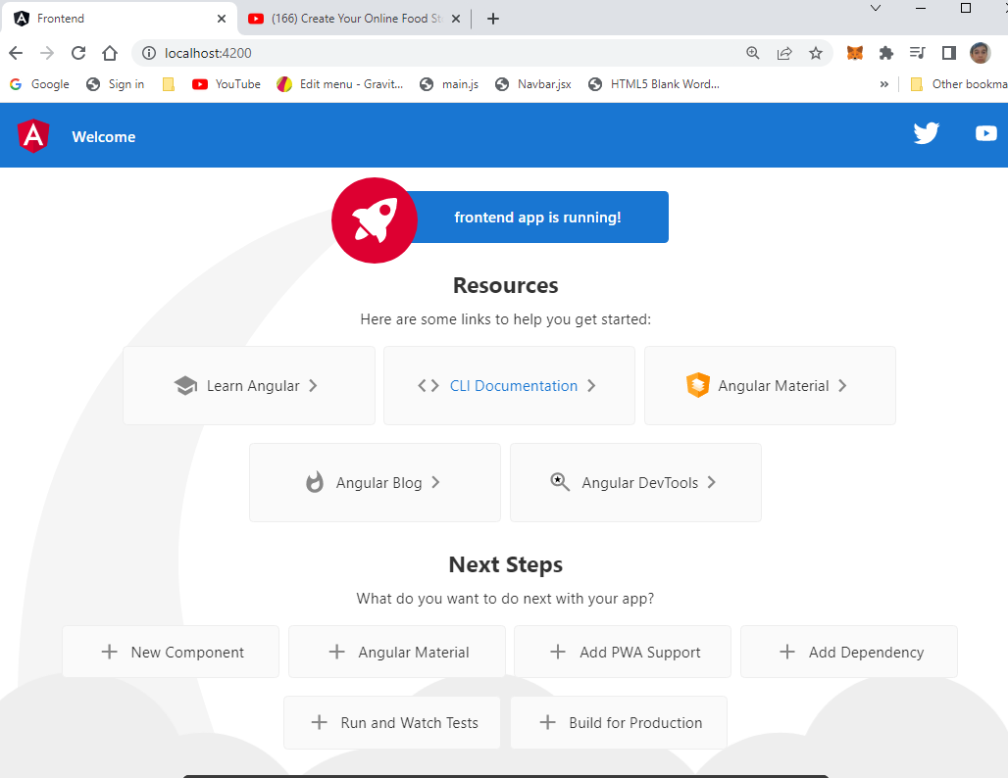

inside your browser it means that you

2:58

are ready for the next video that is

3:00

about adding header to our project

3:06

in this optional but important video i

3:08

want to tell you how to push your

3:11

changes to the github but first of all

3:13

we need to remove git from the

3:15

front-ends folder because when you

3:17

generate a new angular project there is

3:20

a git folder inside it but we want to

3:22

remove it because the front-end folder

3:25

is part of the foodman folder in future

3:28

we're going to have a back-end folder

3:30

here so the changes shouldn't be tracked

3:32

only inside the front end it should be

3:35

tracked in whole food mine project for

3:38

removing git folder from the front end

3:40

folder click on terminal menu and new

3:43

terminal

3:44

go inside the front-end folder then

3:47

write rm-rf.git

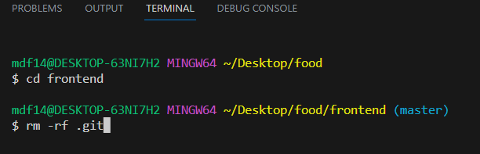

3:50

to remove the git folder and everything

3:53

inside it press enter then close the

3:56

terminal come to the source control tab

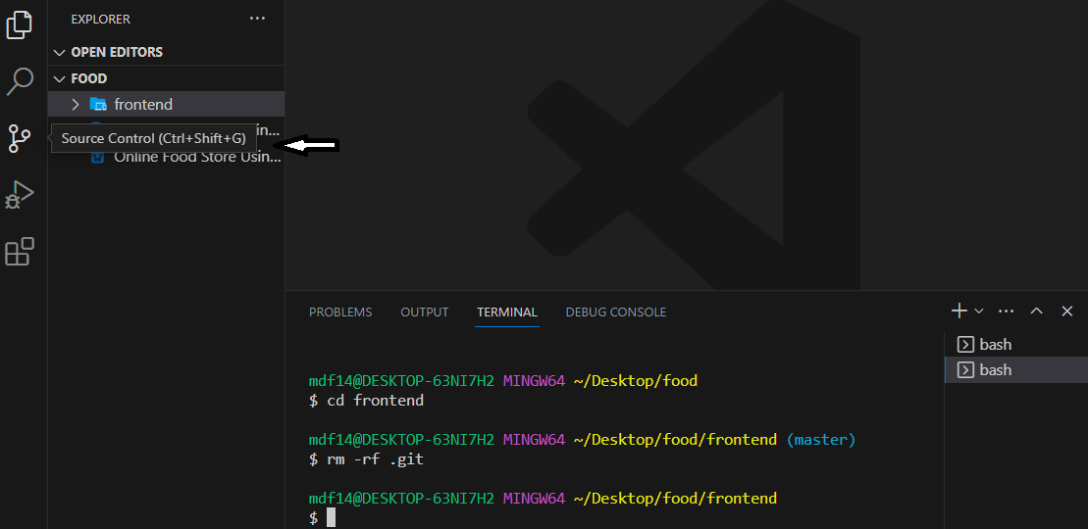

3:58

and click on initialize repository

4:02

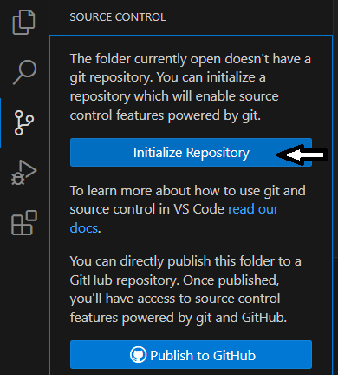

as you can see it tracked all the

4:04

changes but this time from the root

4:06

folder not from the front-end folder

4:09

that's what we want let's write the

4:11

comment message

4:12

create angular app then click on comment

4:16

button to comment your changes

4:20

it says that github extension wants to

4:23

sign in with github click allow

4:27

as you can see it will open up a new

4:29

page inside your browser to get the

4:31

authorization from you click on continue

4:34

then click on

4:36

open visual studio code

4:40

set the name of your repository i want

4:43

to set it to foot mind course here then

4:46

you can select whether you want to push

4:48

your project to a public or private

4:52

repository i want to push this project

4:54

on a public repository so i choose the

4:56

second one this will automatically

4:59

create a new repository inside your

5:01

github and you don't even need to do it

5:04

from the github website now we can click

5:06

on open on github to see our repository

5:10

inside the github's website as you can

5:13

see we have our comment message

5:15

and we have our project here from this

5:18

moment i will push all the code changes

5:22

in each video to the github as a

5:24

separate comment so you can see exactly

5:28

what happened on each video okay this

5:31

was for this video you've been watching

5:33

code vidnas here and i hope to see you

5:35

next time

English (auto-generated)